How to claim your vested PHX

（Extra Compensation for Liquidity Providers）

Introduction
- This document covers the instructions on how to claim vested PHX as compensation for Liquidity Providers (LP). The web3 function on the Phoenix website is currently under development. Until that is completed, users should follow the instructions in this document to claim their funds.

- Vesting contracts do not charge any fee or ask for any token. Please confirm the address in this document before you submit your transaction on-chain.

- Contract addresses:
BSC：
https://bscscan.com/address/0x481fa2731e503ef7d548b98285165eb0c81384f4#readProxyContract
Polygon：(In order to save on gas fees when claiming, we recommend users on Ethereum to claim vested PHX on Polygon.)
https://polygonscan.com/address/0x5bc9de01a94e89a368dc95684603ba72cc0090ef#readProxyContract
Wanchain: (Please notice that as Wanscan does not support this function, users will need to wait for the Web3 function to become operative on the Phoenix website.)
https://wanscan.org/address/0x18e243aef86b4fF3De99Cd0eE1E4333Ca5DF56E5

- Please install Metamask or an equivalent wallet. The address should be able to sign the contract through the wallets on Etherscan.

- If you want to check the amount and chain of your compensation in the snapshot please click this link:
https://docs.google.com/spreadsheets/d/1tXQtpC6oHQ5syELzVZCxDpOsU4QYjBj_5NQS8BCrhSw/htmlview

Withdrawing PHX
Please go to ‘contract→Write as Proxy’:
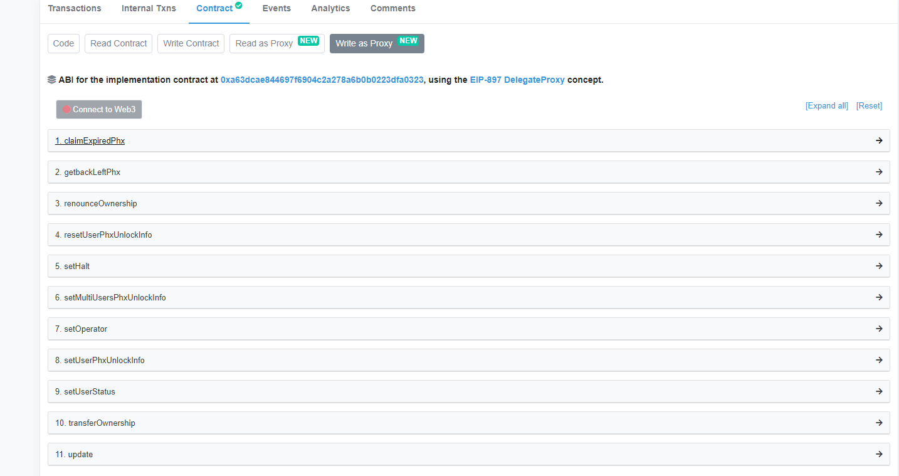
Please follow the steps below:
- Log in your wallet. (Metamask or other.)
- Select your account.
- Press ‘Connect to Web3’. It should appear in green when connected.
- Press ‘1.claimExpiredPhx’.
- Press ‘write’.
- Sign the transaction through your wallet and claim the PHX.

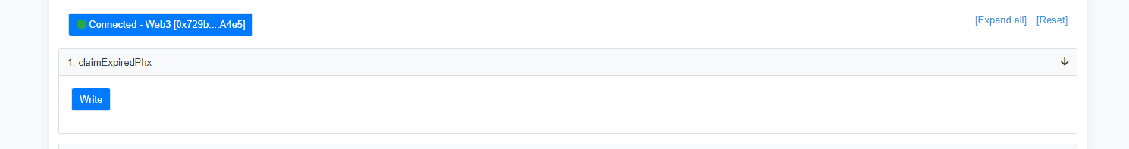

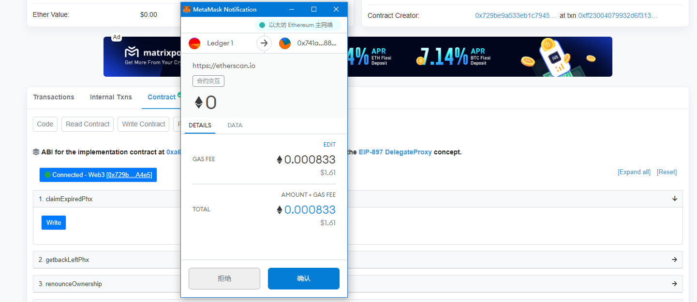

Checking your balance
Please go to ‘contract→Read as Proxy’:
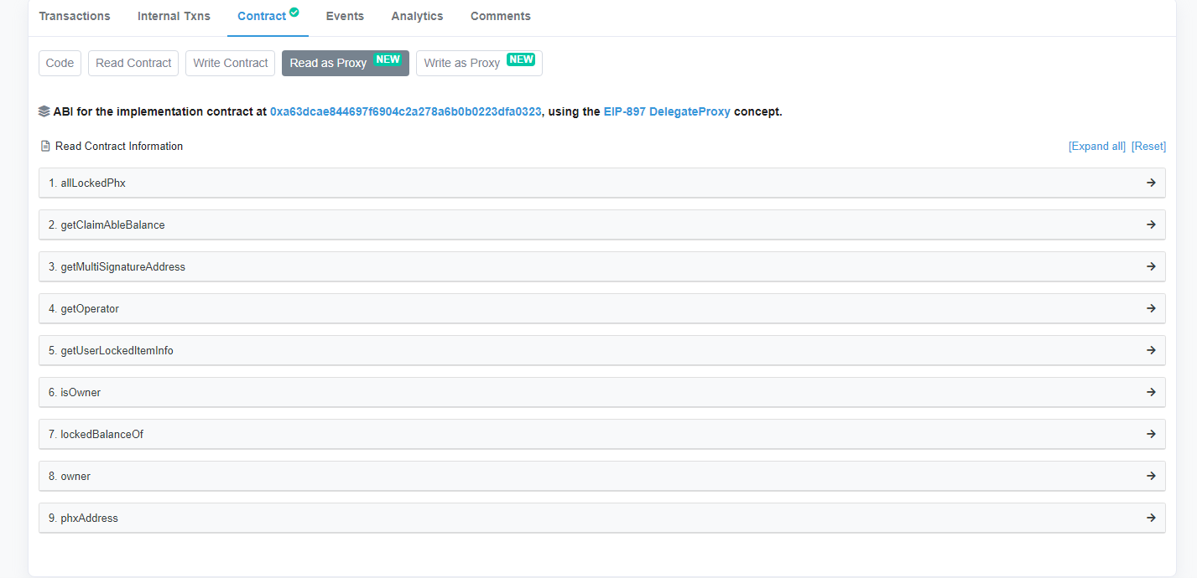

Checking your locked PHX balance
Go to ‘7. lockedBalanceOf’ and input your address, then press ‘query’. The locked PHX balance will be shown.
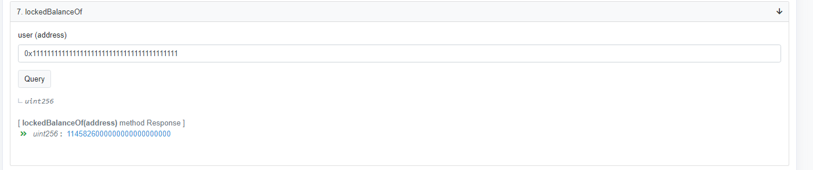

Checking claimable PHX balance
Go to ‘2. getClaimableBalance’ and input your address, then press ‘query’. The claimable PHX balance will appear.

